„POČÍTÁME KORUNY“
Násobilka 3 :
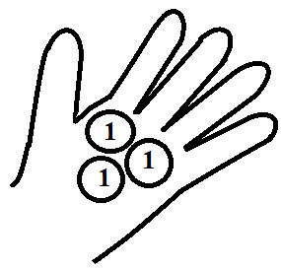
0 + 3 = 3 1 x 3 = 3

3 + 3 = 6 2 x 3 = 6

3 + 3 + 3 = 9 3 x 3 = 9

3 + 3 + 3 + 3 = 12 4 x 3 = 12

3 + 3 + 3 + 3 + 3 = 15 5 x 3 = 15

3 + 3 + 3 + 3 + 3 + 3 = 18 6 x 3 = 18

3 + 3 + 3 + 3 + 3 + 3 + 3 = 21 7 x 3 = 21

3 + 3 + 3 + 3 + 3 + 3 + 3 + 3 = 24 8 x 3 = 24

3 + 3 + 3 + 3 + 3 + 3 + 3 + 3 + 3 = 27 9 x 3 = 27

3 + 3 + 3 + 3 + 3 + 3 + 3 + 3 + 3 + 3 = 30 10 x 3 = 30

