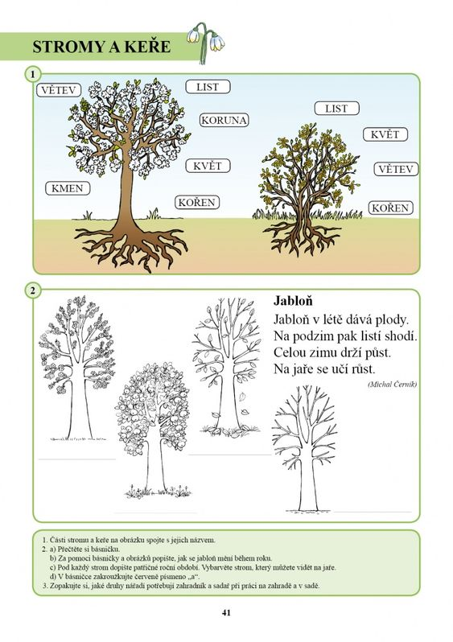
Zdroj: https://cz.pinterest.com/pin/181410691227460904/?nic_v1=1aZESm6mgR0U0BYzlwmNWnEXoaLX%2BgRXQlgBuI5PQtUkNTKbBTTQVYw2sDdBn6pVbz

