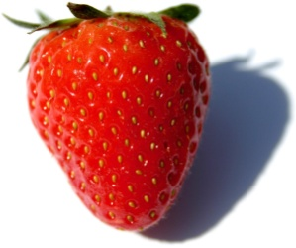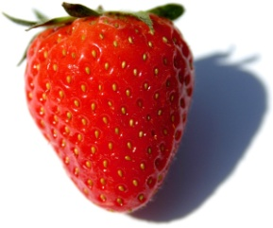

…………………………………………………………………………………………………………………………………………………………….

…………………………………………………………………………………………………………………………………………………………….

…………………………………………………………………………………………………………………………………………………………..

…………………………………………………………………………………………………………………………………………………………….
Úkol: Poznáš názvy českých filmů?
Zdroj obrázků:
https://www.google.cz/search?q=slun%C3%AD%C4%8Dko&tbm=isch&ved=2ahUKEwi2kMGFm-roAhUP_6QKHftdAUUQ2-cCegQIABAA&oq=slun%C3%AD%C4%8Dko&gs_lcp=CgNpbWcQAzIECAAQQzICCAAyAggAMgIIADIECAAQQzICCAAyAggAMgIIADICCAAyAggAOgQIIxAnUIRTWKtjYPxmaABwAHgAgAGYAYgBgwWSAQMyLjSYAQCgAQGqAQtnd3Mtd2l6LWltZw&sclient=img&ei=V-CWXvaII4_-kwX7u4WoBA&authuser=0&bih=937&biw=1920&hl=cs#imgrc=wYxUGk4YVJmOFM&imgdii=fodIgmh27oSx9M

https://www.google.cz/search?q=seno&tbm=isch&ved=2ahUKEwjw8MGMm-roAhVH3KQKHaQwBucQ2-cCegQIABAA&oq=seno&gs_lcp=CgNpbWcQDDICCAAyAggAMgIIADICCAAyAggAMgIIADICCAAyAggAMhttps://pixabay.com/cs/photos/sl%C3%A1ma-seno-zem%C4%9Bd%C4%9Blstv%C3%AD-p%C5%99%C3%ADroda-3328951/
https://cs.wikipedia.org/wiki/Jahoda
https://cz.depositphotos.com/4229838/stock-photo-hazelnut.html
https://www.koule.cz/novinky/vite-co-je-bambiho-komplex-a-syndrom-popelky-10-mentalnich-poruch-pojmenovanych-podle-disneyho-pohadek/
https://fotky-foto.cz/fotobanka/par-sklenic-na-sampanske-prazdninovy-pripitek(4-133032890)/
https://pixers.cz/fototapety/duch-70885397
https://fotky-foto.cz/fotobanka/tri-kostky-ledu-na-bilem-pozadi(4-49921413)/
https://cz.pinterest.com/pin/411727590916625362/

