Dřeviny a byliny
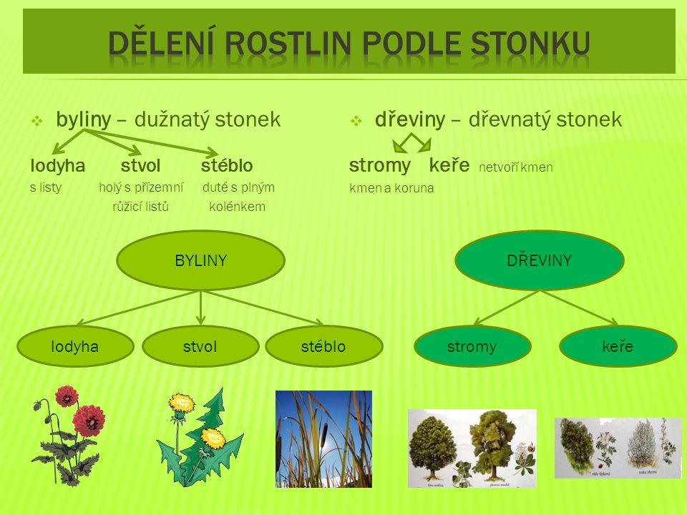
Byliny dřeviny
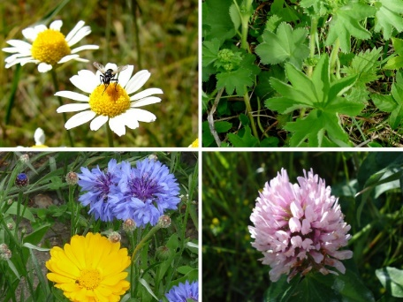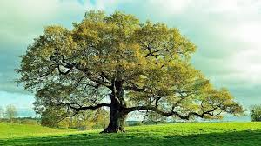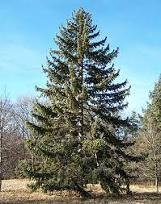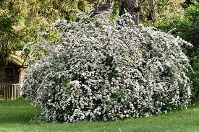

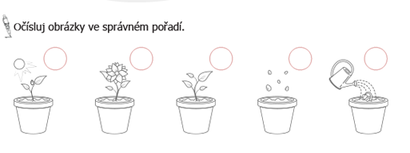
Stavba těla bylin
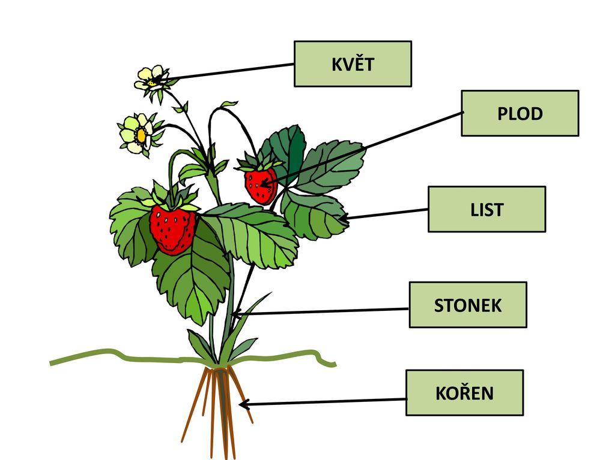
Stavba těla dřevin

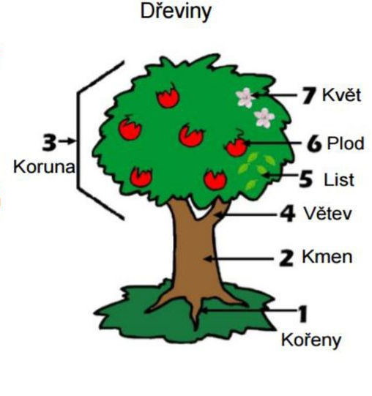
KOŘEN

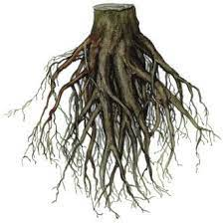

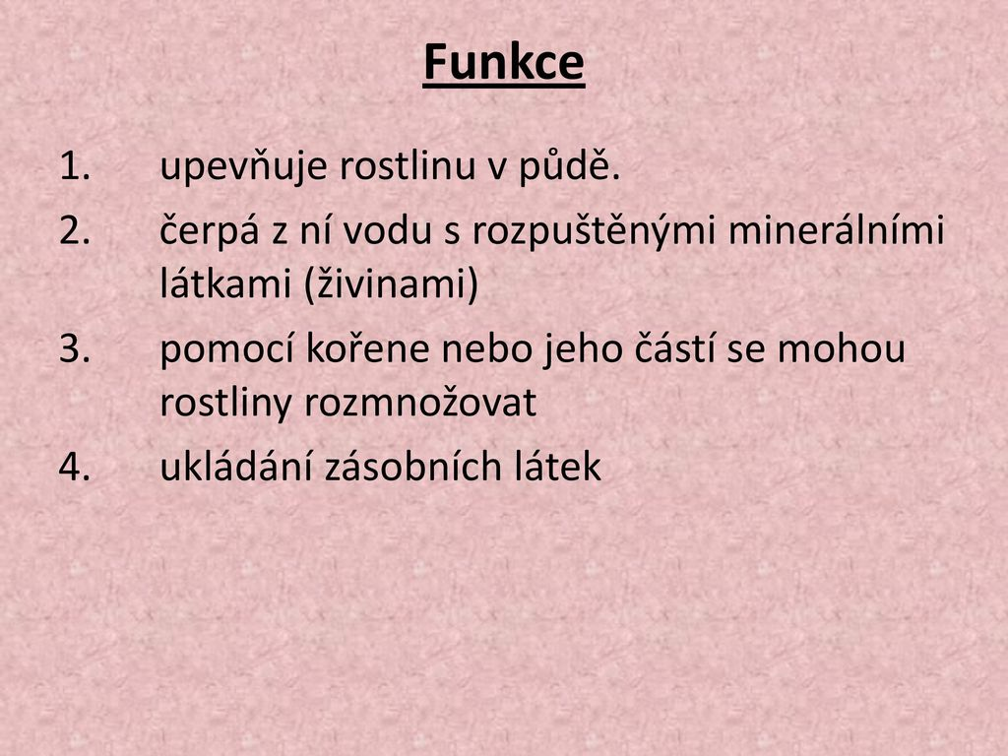

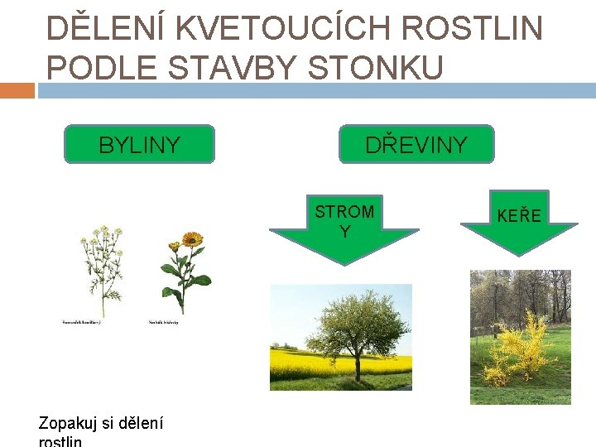

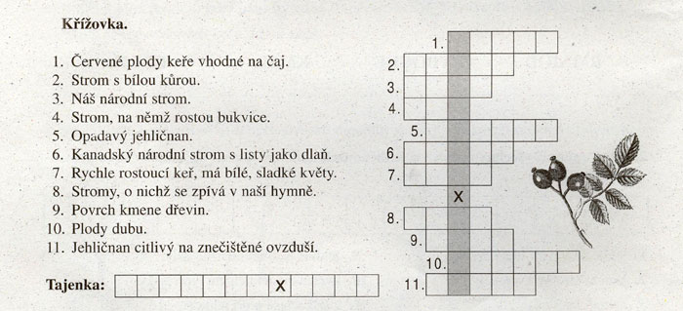
Vylušti křížovku
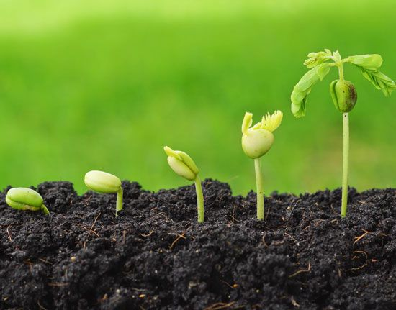Klíčení rostlin

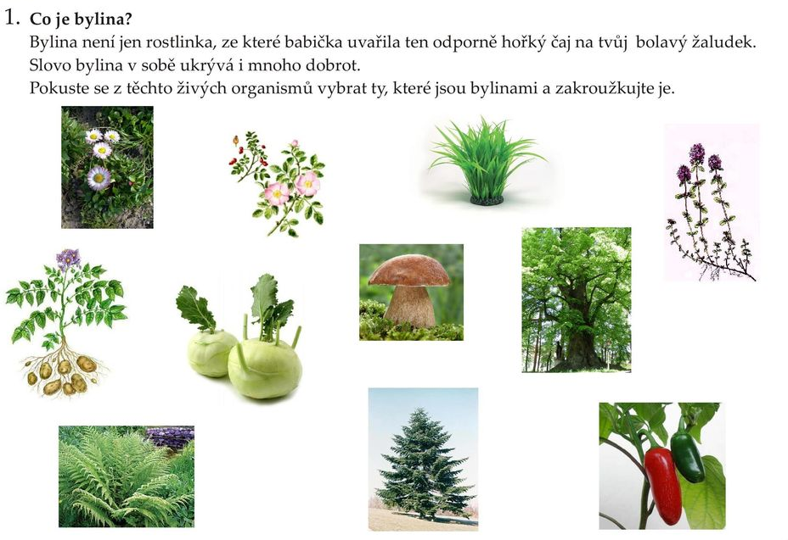
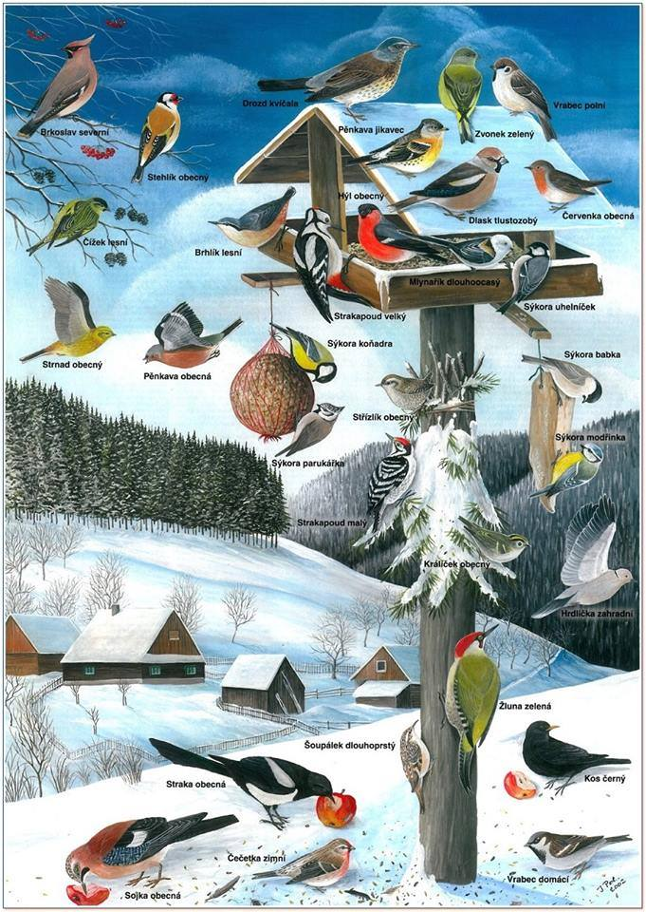

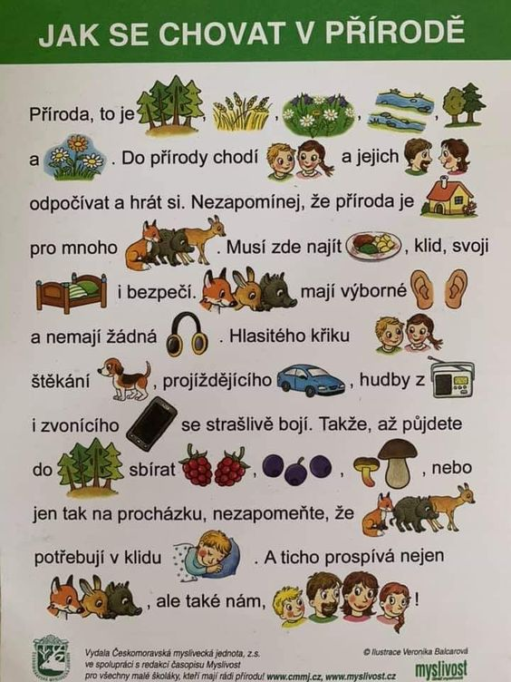

Zdroj obrázků:
https://cz.pinterest.com/pin/127860076905808198/
https://www.google.cz/search?q=stavba+t%C4%9Bla+rostliny&sxsrf=ALeKk01W878m4qF6p6oSOF4aPmsUVzY7Vg:1616875633605&tbm=isch&source=iu&ictx=1&fir=67aBpKyfmq9dIM%252Czp-yT44LPB3PxM%252C_&vet=1&usg=AI4_-kSQ0OPx0Rv0L_8TRh8E6tCh7DloHw&sa=X&ved=2ahUKEwiVsaWOo9HvAhVlBhAIHRiwB08Q9QF6BAgKEAE&biw=1280&bih=578&dpr=1.5#imgrc=67aBpKyfmq9dIM&imgdii=7e1Cl09JLqnPmMhttps://www.google.cz/search?q=stavba+t%C4%9Bla+rostliny&sxsrf=ALeKk01W878m4qF6p6oSOF4aPmsUVzY7Vg:1616875633605&tbm=isch&source=iu&ictx=1&fir=67aBpKyfmq9dIM%252Czp-yT44LPB3PxM%252C_&vet=1&usg=AI4_-kSQ0OPx0Rv0L_8TRh8E6tCh7DloHw&sa=X&ved=2ahUKEwiVsaWOo9HvAhVlBhAIHRiwB08Q9QF6BAgKEAE&biw=1280&bih=578&dpr=1.5#imgrc=67aBpKyfmq9dIM&imgdii=7e1Cl09JLqnPmM
https://cz.pinterest.com/pin/42291683977536200/
https://www.google.cz/search?q=stavba+t%C4%9Bla+d%C5%99evin&tbm=isch&ved=2ahUKEwiM_MKQo9HvAhUI9hoKHRESAxYQ2-cCegQIABAA&oq=stavba+t%C4%9Bla+d%C5%99evin&gs_lcp=CgNpbWcQAzoECAAQQzoCCAA6BggAEAgQHjoECCMQJ1CDjHFYjLRxYMq4cWgBcAB4AIABowGIAcQKkgEEMTEuNJgBAKABAaoBC2d3cy13aXotaW1nwAEB&sclient=img&ei=dpBfYIzpEIjsa5GkjLAB&bih=578&biw=1280#imgrc=FYU2jmxqYW0vDM
https://slidetodoc.com/z-tnec-nad-labem-autor-mgr-iveta-hejtmnkov-9/
https://www.google.cz/search?q=d%C4%9Blen%C3%AD+rostlin&tbm=isch&ved=2ahUKEwiagZLZqtHvAhUHeRoKHcbTCz0Q2-cCegQIABAA&oq=d%C4%9Blen%C3%AD+rostlin&gs_lcp=CgNpbWcQAzICCAAyAggAMgIIADICCAAyAggAMgIIADIGCAAQCBAeMgYIABAIEB4yBAgAEBgyBAgAEBg6BAgjECc6BwgjEOoCECc6BAgAEEM6BQgAELEDUJ_PCFjyoglg0acJaAJwAHgCgAGsAYgBkBaSAQQyMy45mAEAoAEBqgELZ3dzLXdpei1pbWewAQrAAQE&sclient=img&ei=ZZhfYNq6JYfyacanr-gD&bih=578&biw=1280#imgrc=5L2uCDA8GehiYM
https://www.google.cz/search?q=ke%C5%99&tbm=isch&ved=2ahUKEwiVyOaHrtHvAhUO1IUKHfveC08Q2-cCegQIABAA&oq=ke%C5%99&gs_lcp=CgNpbWcQAzICCAAyAggAMgIIADICCAAyAggAMgIIADICCAAyAggAMgIIADICCAA6BAgjECc6BQgAELEDOgQIABBDOgcIIxDqAhAnUMn3A1juhwRg8IwEaAFwAHgAgAGCAYgB7wOSAQM1LjGYAQCgAQGqAQtnd3Mtd2l6LWltZ7ABCsABAQ&sclient=img&ei=7JtfYJWiL46olwT7va_4BA&bih=578&biw=1280
https://www.google.cz/search?q=ko%C5%99en+funkce&tbm=isch&ved=2ahUKEwjEx-zfq9HvAhXM0oUKHQcvD08Q2-cCegQIABAA&oq=ko%C5%99en+funkce&gs_lcp=CgNpbWcQAzICCAA6BAgAEEM6BggAEAgQHjoECAAQGFDO4wFYvvgBYJj9AWgAcAB4AIABmwGIAdgGkgEDMS42mAEAoAEBqgELZ3dzLXdpei1pbWfAAQE&sclient=img&ei=gJlfYMSHB8yllwSH3rz4BA&bih=578&biw=1280#imgrc=gHHPwM4wyA1IjM
https://www.google.cz/search?q=ko%C5%99en+&tbm=isch&ved=2ahUKEwjUzenvq9HvAhU1gc4BHUsNAmAQ2-cCegQIABAA&oq=ko%C5%99en+&gs_lcp=CgNpbWcQAzIECCMQJzICCAAyAggAMgIIADICCAAyAggAMgIIADICCAAyAggAMgIIADoGCAAQCBAeOgQIABAYUKyYBliwpAZggqsGaABwAHgAgAGSAYgB6AOSAQM1LjGYAQCgAQGqAQtnd3Mtd2l6LWltZ8ABAQ&sclient=img&ei=oZlfYJT5JbWCur4Py5qIgAY&bih=578&biw=1280#imgrc=IOP3JherKpPr_M&imgdii=nv3ngfpl041RlM

https://www.google.cz/search?q=byliny&tbm=isch&ved=2ahUKEwj84fGhrNHvAhVBZxoKHSfJCOgQ2-cCegQIABAA&oq=byliny&gs_lcp=CgNpbWcQAzICCAAyAggAMgIIADICCAAyAggAMgIIADICCAAyAggAMgIIADICCAA6BAgjECc6BAgAEEM6BQgAELEDOgcIIxDqAhAnUPzNC1je5Qtgx-0LaAFwAHgAgAGkAYgBqgaSAQM4LjKYAQCgAQGqAQtnd3Mtd2l6LWltZ7ABCsABAQ&sclient=img&ei=CppfYPy0JcHOaaeSo8AO&bih=578&biw=1280#imgrc=r9tfLmGINoKm_M&imgdii=xglo6qH6-6n1sM

https://www.google.cz/search?q=strom&tbm=isch&ved=2ahUKEwjso9G4rdHvAhVJ9hoKHawFDtIQ2-cCegQIABAA&oq=strom&gs_lcp=CgNpbWcQAzIFCAAQsQMyAggAMgIIADICCAAyAggAMgIIADICCAAyAggAMgIIADICCAA6BAgjECc6BwgjEOoCECc6CAgAELEDEIMBUOjRBFiS5wRgqusEaAFwAHgCgAF9iAHPB5IBAzkuMpgBAKABAaoBC2d3cy13aXotaW1nsAEKwAEB&sclient=img&ei=RptfYOzoLcnsa6yLuJAN&bih=578&biw=1280

https://www.google.cz/search?q=smrk&tbm=isch&ved=2ahUKEwiF7fverdHvAhUOsxoKHSAnA5cQ2-cCegQIABAA&oq=smrk&gs_lcp=CgNpbWcQAzIHCAAQsQMQQzIECAAQQzICCAAyAggAMgIIADICCAAyAggAMgIIADICCAAyAggAOgQIIxAnOggIABCxAxCDAToFCAAQsQNQqP4EWOyQBWD4lAVoAHAAeACAAVuIAbAEkgEBN5gBAKABAaoBC2d3cy13aXotaW1nwAEB&sclient=img&ei=l5tfYMXFCI7maqDOjLgJ&bih=578&biw=1280

https://cz.pinterest.com/pin/3940718414867052/

